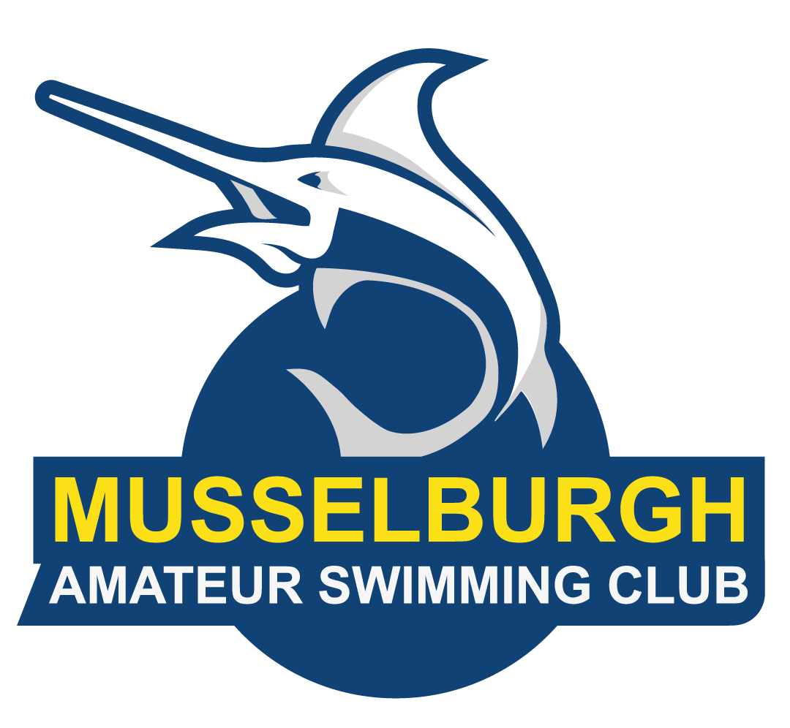
Musselburgh Amateur Swim Club
Summer Fun Meet

Saturday 13th June 2026

Mercat Gait Centre, Prestonpans

Licence Number: L3/ED/024/JUN26

Licenced by: SASA East District

Accreditation: SASA Level 3 Licenced Meet

Venue: Mercat Gait Sports Centre, Prestonpans, East Lothian, EH32 9EN

Pool: 6-Lane, 25 metre, full electronic timing with 3-lane display scoreboard, non-turbulence lane dividers

Events: 8-10 years – 50m Butterfly, Backstroke, Breaststroke and Freestyle
11 years and older - 100m Butterfly, Backstroke, Breaststroke and Freestyle
8-11 years and older - 100m IM
8-11 years mixed - 4x50 Freestyle Relay
12 years and older - 4x50 Freestyle Relay

Age groups: 8 years
9 years
10 years
11 years
12 years
13 years
14 years and older
Age as at 13th June 2026.
Events will be run in mixed age groups and results sorted by age groups. Medals will be awarded to the top 3 swimmers in each age group and the top three teams in the relay events.
Relay Rules: Relays must be made up of mixed gender of any combination, i.e. 2+2 or 3+1

Sessions: There will be a morning and afternoon session.

Morning Warm-up 09.00 – 09.50
Start 10.00
Finish 13.00

Afternoon Warm-up 13.00 – 13.50
Start 14.00
Finish 17.00

Entry fees: Individual Entry fees - £6 per swim, and £7 per relay team entry

Entry closing date: Friday 15th May (12 noon)

Technical Officials: To ensure accreditation, we would appreciate if visiting Clubs could assist by
providing technical officials. All Clubs are required to nominate 2 officials per
session to ensure the smooth running of the meet. Please send details of the support your club will provide to mascstocoordinator@gmail.com prior to Saturday the 30th of May (12 noon).
Meet Rules

- The current World Aquatics and SASA rules of competitive swimming will apply.
- Age as at 13th June 2026.
- All swimmers must have a current SASA or equivalent registration number.
- The pool is 25-metres long with 6-lanes separated by anti-turbulent lane ropes.
- Electronic timing will be in operation. In the event of electronic timing failure, then back-up manual timing will be used.
- Mobile telephone MUST NOT be used in showers, changing village and toilets under any circumstances.
- Swimmers must act on the instructions given by the meet officials and behave in a reasonable manner at all times.
- It is the responsibility of each club to ensure that their swimmers are aware of the meet rules and guidelines.
- The meet will adhere to Scottish Swimming “Swimwear Policies”. The policies are included in full in the appendices of Scottish Swimming Regulations. These can be found here.

Entries and Events

- Closing date for entries is Friday 15th May (12 noon). Late entries will not be accepted.
- All entries must be made by Hy-Tek entry files and these can be requested via email from masccompetitionsecretary@gmail.com or downloaded from www.swimscotland.co.uk.
- Withdrawals on the day must be made to the recorders no later than 45 minutes prior to the start of each session. There are no refunds for entries withdrawn after the draft programme is published.
- The organisers reserve the right to restrict entries in order to facilitate the smooth running of the meet. In the event of the meet being oversubscribed entries will be cut from the top i.e. fastest swimmers as required. It is the responsibility of Entry Secretaries to ensure all entry times and dates of birth are correct. Rejected entries will be refunded in full. A draft programme will be made available to Entry Secretaries prior to the meet date.
- All events will be Heat Declared Winners.
- Swimmers must report to the designated marshalling area a minimum of four heats in advance. It is the responsibility of the competing teams to ensure that their swimmers report to the marshalling area on time.

Warm up

- Warm up may only commence when advised to do so.
- No diving other than in sprint lanes.
- Swimmers must keep moving during warm-up to avoid congestion in the pool.
- The meet stewards will determine sprint lanes.
- No congregating allowed at either end of the lanes.

Miscellaneous

- This will be a Level 3 Licensed Meet. Licence Number: L3/ED/024/JUN26
- The Mercat Gait has a cafe and refreshment vending machines.
- The organisers reserve the right to exclude or refuse admission to any competitor, spectator or team official.
- Neither MASC nor the Mercat Gait Leisure Centre can be held responsible for loss or damage to any property. Swimmers should use the lockers provided and not leave belongings lying around unattended. Bags should not be taken onto poolside, they should remain in lockers.
- Swimmers must act on the instructions of the meet officials and behave in a responsible manner at all times.
- No glassware may be taken into the showers or poolside. Anyone doing so will be liable to expulsion from the meet.
- Outdoor footwear must not be worn on the poolside area.
- Swimmers MUST wear dry clothing and footwear at all times when not in poolside area.
- The use of mobile phones is prohibited by the Mercat Gait Leisure Centre anywhere within the changing areas or showers.
- The MASC committee retains the right to amend any of the above conditions as necessary.
- Anything not covered in the above or in the event programme will be at the organisers’ discretion.
- No guarantee can be given by MASC that the event will take place at a particular time, place, or date and MASC reserves the right to reschedule the event without notice and without liability for doing so. It is expected that this would only be as a result of unforeseen circumstances, e.g., venue/facility failure or adverse weather.
- In the event of postponement, cancellation or abandonment of the event, refunds if any, will be made at the absolute discretion of MASC. MASC will have no liability to make a refund or to pay any form of consequential or indirect damage such as loss of enjoyment, travel and accommodation costs.

Controlling the Use of Photographic Equipment
The meet organisers are aware of the wide range of devices including mobile telephones which have photographic and filming capabilities. This enables the capture of both static and moving images. It should be acknowledged that most images taken within Scottish Swimming licensed meets are appropriate and taken in good faith. However, images of children and adults can be misused, and sharing images widely without consent may betray a confidence or identity of a child or adult, which could present a risk of harm to that individual if common sense procedures are not followed.
Parents and carers of participants under the age of 18 who wish to take images are requested to focus on their own children as much as reasonably possible and to avoid including other children in images, particularly if those images are being shared with family and friends or through social media platforms.
Whilst it is acknowledged that parents/carers wish to celebrate the achievements of their own children when taking part in aquatic events, it should be recognised and respected that other parents/carers may not wish for their child’s images to be taken and shared in this way. The meet organisers are committed to ensuring that all children who participate in this meet can take part in an enjoyable, safe environment and be safeguarded from harm. If there are any child safeguarding concerns at the event, please contact the Events Convenor immediately to disclose your concerns.
Please find a link to the Scottish Swimming wellbeing statement here.

Transgender & Non-Binary Competition
The Scottish Swimming Transgender & Non-Binary Competition Policy was implemented on 1st January 2024. The policy and FAQs can be found HERE. Any policy related matters that arise during the event should be reported to and will be recorded by the Meet Convenor/Lead Referee and these matters will be communicated to and managed post event by the relevant Scottish Swimming Staff. At no point will members be challenged on the day of a competition with any matters being resolved post event. By entering the Female category, athletes are therefore confirming their birth sex is female and are eligible to compete in the Female category.
Safeguarding
The primary safeguarding point of contact for the event in relation to wellbeing & protection matters or accidents is the Meet Organiser. The secondary point of contact is the Scottish Swimming Safeguarding Manager.
Events
Session 1
Warm up 09.00
Start 10.00

Session 1 - Morning
101 | Mixed | 11 years and over | 100m Butterfly
102 | Mixed | 10 years and under | 50m Breastroke
103 | Mixed | 11 years and over | 100m Freestyle
104 | Mixed | 10 years and under | 50m Backstroke
105 | Mixed | 8 years and over | 100m IM

Session 2 (Age 11 and over)
Warm up 13.00
Start 14.00
Session 2 - Afternoon
201 | Mixed | 11 years and over | 100m Backstroke
202 | Mixed | 10 years and under | 50m Butterfly
203 | Mixed | 11 years and over | 100m Breaststroke
204 | Mixed | 10 years and under | 50m Freestyle
205 | Mixed | 8 - 11 years | 4 x 50 Freestyle Relay
206 | Mixed | 12 years and over | 4 x 50 Freestyle Relay

Entry Form
Return this form with entry file no later than Friday 15th May (12 noon) masccompetitionsecretary@gmail.com

Payment where possible should be made by BACS. Please reference the payment “SUMMER” followed by your club code e.g. SUMMER UELX
Bank Account Details
Sort Code: 80-17-68 Account No: 00221095
Contact: MASCclubtreasurer@gmail.com

Named STO’s and Timekeepers

Clubs are required to nominate 2 officials per session to ensure the smooth running of the meet.
Club:

Name | Position | Session | Preferred Role | Contact Details
 | STO/TK | 1[ ]  2[ ]
 | STO/TK | 1[ ]  2[ ]
 | STO/TK | 1[ ]  2[ ]
 | STO/TK | 1[ ]  2[ ]
 | STO/TK | 1[ ]  2[ ]
 | STO/TK | 1[ ]  2[ ]
 | STO/TK | 1[ ]  2[ ]

Please complete electronically and return no later than 23rd May 2026 to mascstocoordinator@gmail.com

Thank you for your assistance

